Clinical Research Associate
Pearl Pathways

Pharmaceutical and device companies need to navigate through many hurdles as they develop drugs, devices and diagnostics that improve and save human life. Pearl Pathways supports companies in their development, clinical research, manufacturing and marketing of these products.

Service offerings for Pearl Pathways include:
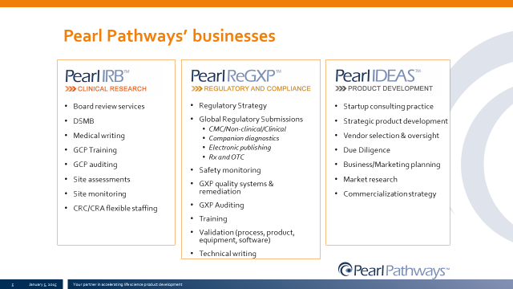

Position
Clinical Research Associate

Job Description
The Clinical Research Associate is responsible for coordination and conduct of clinical research activities either for the sponsor or at a research site. This role will have the day to day responsibility for clinical research ensuring studies are conducted in accordance with the protocol, relevant SOPs and good clinical practices. This role could also provide Pearl IRB administrative oversight, as well as serve on the IRB as a member. This position may also include medical writing services (protocols, ICFs, CSRs, manuscripts), site feasibility, initiation and closeout visits for clients. Finally, this role may provide GCP quality compliance services for clients including creation of quality system SOPs, gap analyses of research study documentation, and other internal quality compliance services for Pearl IRB’s quality management system. This individual must be detail oriented and possess good communication skills. Device experience is preferred for this role.

Responsibilities include:
- Initiation, monitoring and completing clinical studies
- Writing or editing for clinical research studies
- Coordinate IRB submission activities
- Serve on IRB as Board member
- If filling role of CRC, will manage day to day activities with PI, consent subjects, host monitoring visits, and data entry if required
- Provide study monitoring services if acting for sponsor (SIF, SIV, COV)
- Ensure clinical research is conducted as planned and in accordance with federal and local regulations
- Assist with regulatory submissions (IND, IDE)
- Provide study quality assurance activities
- Provide GCP quality compliance and quality assurance activities
- Direct interface with the clients and subjects
- Reports updates and potential issues to the COO and client

Training Requirements:
At least 3 years clinical research experience in CRC and/or CRA roles required. Monitoring experience is a plus. SOCRA or ACRP certification preferred. GCP training required. Training on company and local client SOPs will be required.

Skills and Competencies:
- Strong written and verbal communication skills
• Strong interpersonal skills
• Strong computer skills, including Microsoft Office
• Working knowledge of GCP/ICH and ISO 14155 guidelines
• Knowledge of medical terminology
• Independent and with a sense of urgency
• Able to exercise judgment within defined procedures and practices and to determine appropriate action independently
• Able to handle multiple projects in parallel
• Able to work in a dynamic, changing environment
• Attention to detail
• Problem-solving skills
• Strong team player
• Organized and flexible

Other: Willing to travel up to 50% of the time

Company Description
Pearl Pathways (www.pearlpathways.com) is a comprehensive life science product development services company. Our experienced team is obsessed with expediting life science product development regulatory pathways. We have three business units to serve our clients:
- Pearl IRB (www.pearlirb.com) is a full service commercial Independent Review Board that provides human research IRB reviews, IRB exemptions and waivers, and also offers support for research protocol/ICF medical writing, site assessments, and monitoring services.
- Pearl ReGXP is a regulatory and quality compliance consulting practice that provides regulatory filing guidance, conducts global health authority negotiations, develops/improves quality systems, and delivers GMP/GLP/GCP auditing services.
- Pearl IDEAS provides strategic product development assistance, third party vendor selection and management strategies, due diligence services, and sales and marketing services for drug, biologic and device companies.
To learn more, contact us at contact@pearlpathways.com or visit us at www.pearlpathways.com.

